

Foundations of Programming

Lab Assignment No. : 02

PROBLEM STATEMENT:
Write a menu driven program in C to implement the basic arithmetic operations such as Addition, Subtraction, Multiplication, and Division.

OBJECTIVES:
• To understand the concept of menu driven programming in C.
• To apply conditional statements and switch–case control structures.
• To perform basic arithmetic operations using user-defined input.
• To enhance logical thinking and problem-solving skills.

THEORY:
- if–else ladder statements syntax and sample program:
The if–else ladder statement is a decision-making control structure in C that is used to evaluate multiple conditions sequentially. It allows the program to execute one block of code among many alternatives based on the satisfaction of conditions.
Working Principle
- Conditions are checked from top to bottom
- As soon as a condition evaluates to true, the corresponding block is executed
- Remaining conditions are skipped
- If none of the conditions are true, the else block is executed
Characteristics
- Used when conditions involve ranges or relational expressions
- Supports logical operators (&&, ||, !)
- Suitable when the number of conditions is large
Syntax :
if (condition1) {
// code
}
else if (condition2) {
// code
}
else if (condition3) {
// code
}
else {
// default code
}

Advantages
- Easy to understand and implement
- Flexible for complex conditions
Disadvantages
- Execution time increases with more conditions
- Less readable when ladder becomes long

- switch–case Statement
Definition
The switch–case statement is a multi-branch decision control structure that allows a variable or expression to be tested against multiple constant values. Based on the matched case, the corresponding block of code is executed.
Working Principle
- The expression in the switch is evaluated once
- Control jumps to the matching case
- Statements execute until a break is encountered
- default executes if no case matches
Characteristics
- Works only with integer or character constants
- Does not support relational or logical expressions
- Faster and more structured than if–else ladder
Syntax
switch (expression) {
case constant1:
statements;
break;
case constant2:
statements;
break;
default:
statements;
}
Advantages
- Improved readability
- Faster execution
- Easy to maintain
Disadvantages
- Cannot handle range conditions
- Requires break to avoid fall-through

- Basic arithmetic operations include Addition, Subtraction, Multiplication, and Division. Division by zero should be avoided.
Definition
Arithmetic operations in C are used to perform mathematical calculations on numeric data. These operations form the foundation of all computational programs.
Types of Arithmetic Operations
- Addition (+)
Adds two operands.
Example: a + b
- Subtraction (−)
Subtracts second operand from first.
Example: a - b
- Multiplication (*)
Multiplies two operands.
Example: a * b
- Division (/)
Divides numerator by denominator.
Example: a / b
Division by zero occurs when the denominator of a division operation is zero. In C, this results in a runtime error and causes program termination or undefined behavior.
Reason for Avoidance
- Zero cannot divide any number mathematically
- Leads to program crash or incorrect output
Prevention Method
Always check the denominator before performing division using a conditional statement.
ALGORITHM:
  - Start
  - Display menu :
- Addition (+)
- Subtraction (-)
- Multiplication (*)
- Division (/)
- Remainder (%)
- Exit
  - Declare variables op, r.
  - Accept the choice from menu and store in op
  - If the choice is between 1-5, accept a & b (two numbers).
  - If op is 1, add a and b.
If op is 2, subtract b from a.
If op is 3, multiply a and b.
If op is 4, divide a by b.
If op is 5, use % to get remainder of a by b, and store the result in r
  - Display r
  - Else, the choice is 6, display exit.
  - Stop.
FLOWCHART:
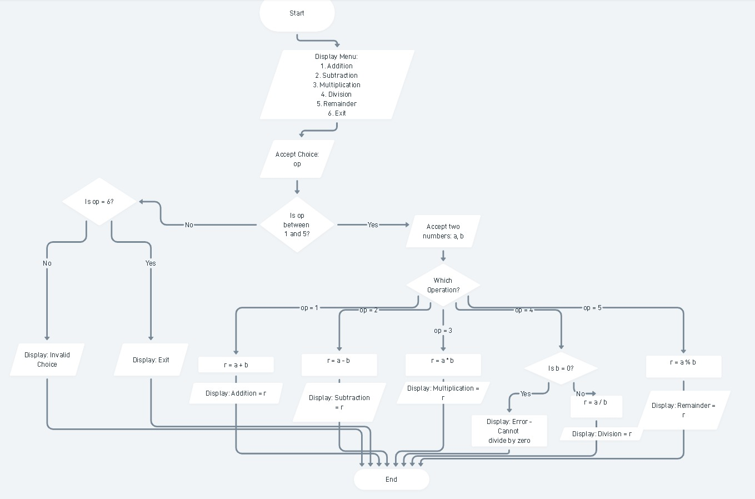

PLATFORM:
Linux

INPUT:
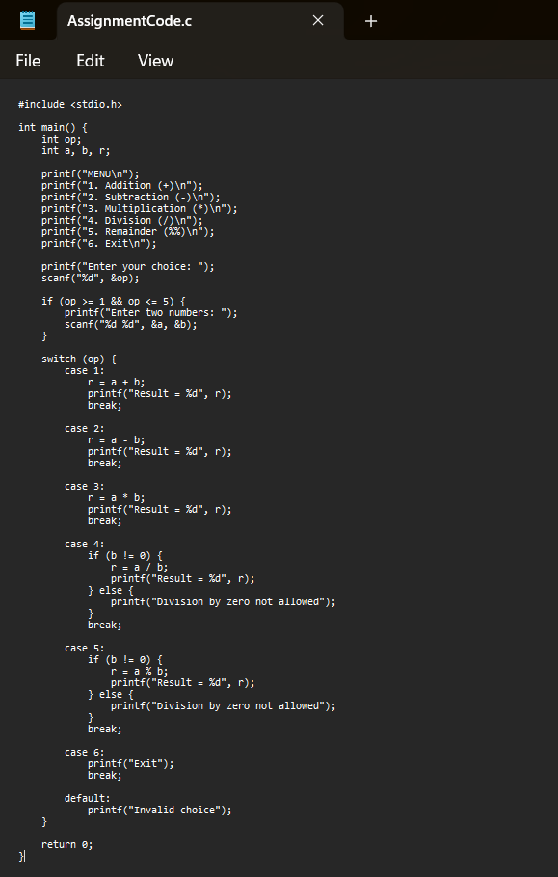

OUTPUT:
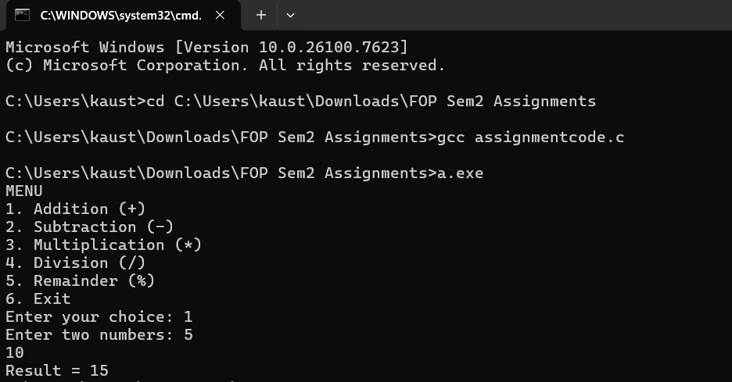

SAMPLE INPUT:
op: 1
5, 10
SAMPLE OUTPUT:
Addition = 15

CONCLUSION:
Thus, the menu driven program in C successfully performs basic arithmetic operations using switch–case statements.

